Chapter 19, Problem 59.

Given that

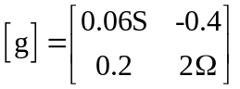

determine:

(a) [z]
(b) [y]
(c) [h]
(d) [T]

